/\*

ASSIGNMENT NO. 5

NAME- ABRAR SHAIKH ROLL NO. - 23570

TOPIC- Binary Tree

\*/

#include <iostream>

using namespace std;

class Node {

public:

int data;

Node \*right;

Node \*left;

// Constructor to initialize a new node

Node(int data) {

this->data = data;

this->right = NULL;

this->left = NULL;

}

};

class BinaryTree {

private:

Node\* root;

Node\* insert(Node\* node, int data) {

if (node == NULL) {

return new Node(data);

}

if (data < node->data) {

node->left = insert(node->left, data);

} else {

node->right = insert(node->right, data);

}

return node;

}

void shift(Node\* node) {

if (node != NULL) {

shift(node->left);

cout << node->data << " ";

shift(node->right);

}

}

Node\* findMin(Node\* node) {

while (node && node->left != NULL) {

node = node->left;

}

return node;

}

Node\* del(Node\* node, int data) {

if (node == NULL) {

return NULL;

}

if (data < node->data) {

node->left = del(node->left, data);

} else if (data > node->data) {

node->right = del(node->right, data);

} else {

// Node with the data is found

if (node->left == NULL) {

Node\* temp = node->right;

delete node;

return temp;

} else if (node->right == NULL) {

Node\* temp = node->left;

delete node;

return temp;

}

Node\* temp = findMin(node->right);

node->data = temp->data;

node->right = del(node->right, temp->data);

}

return node;

}

public:

BinaryTree() {

this->root = NULL;

}

void insert(int data) {

root = insert(root, data);

}

void display() {

shift(root);

cout << endl;

}

void Delete(int data) {

root = del(root, data);

}

};

int main() {

BinaryTree tree;

int choice;

while (true) {

cout << "Select operation to perform : \n1. Insert \n2. Delete \n3. Display \n4. Exit" << endl;

cin >> choice;

if (choice == 1) {

int value;

cout << "Enter value to insert: ";

cin >> value;

tree.insert(value);

} else if (choice == 2) {

int value;

cout << "Enter value to delete: ";

cin >> value;

tree.Delete(value);

} else if (choice == 3) {

tree.display();

} else if (choice == 4) {

break;

} else {

cout << "Enter a valid choice" << endl;

}

}

return 0;

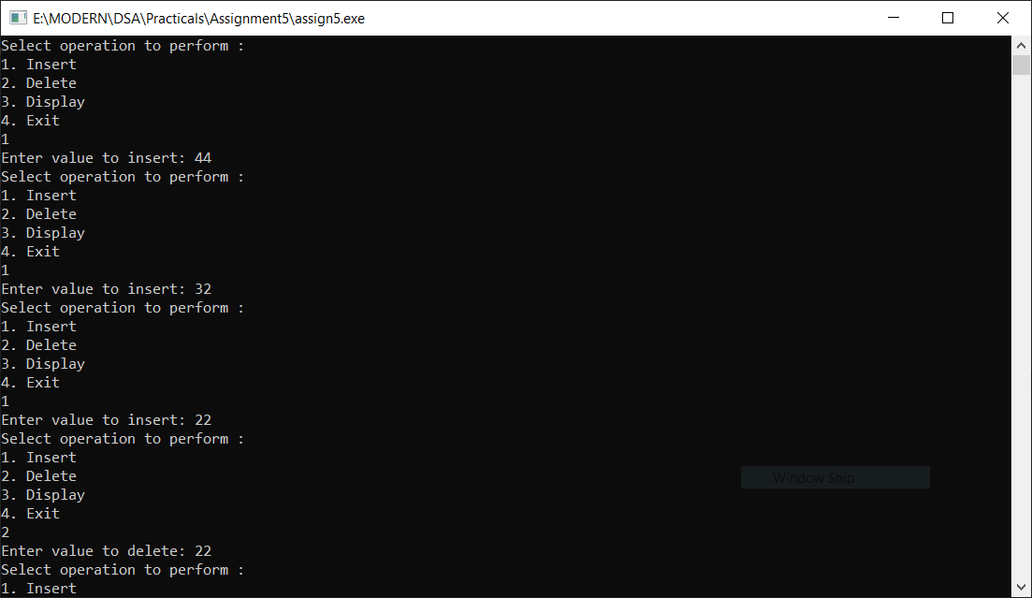}

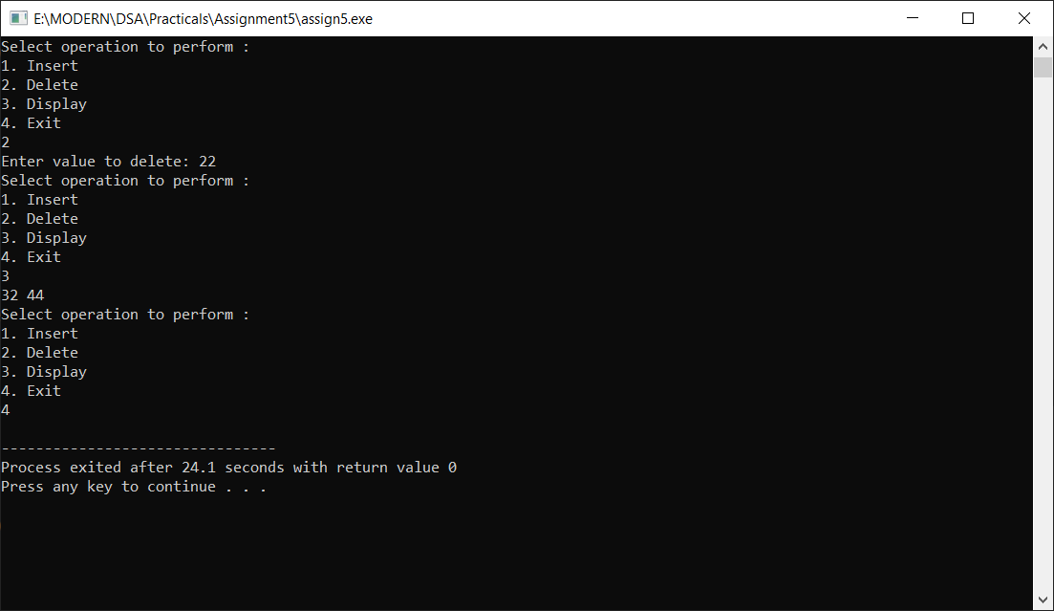

GitHub Repository- https://github.com/abssha/DSA.git